Unit 1 – The Function Toolkit Revisited
Big idea: You already know the basic families of function, but maybe only at a surface level. We’ll quickly review them, and highlight important ways to think about functions. Functions will be the building blocks you’ll use to make stuff later. You’ll be combining them and transforming them to do things. BUT you’ll need to have them all memorized so you can think about which ones to choose for a particular problem.
Topics.
1 – 1. Families of functions
1 – 2. Transforming functions 1. Recognizing/applying transformations to functions.
1 – 3. Transforming functions 2. Solve for a transformation that fits a function to a point.
1 – 4. Function domains
1 – 5. Function composition
1 – 6. Function inverses
1 – 7. Fitting a function to data (by setting up and solving a system of equations)

Mathematical discovery – Card Shuffling
How many perfect interleving shuffles does it take to put a deck of cards back in the original order?

Insights & Takeaways from this problem.
The purpose of this problem was to show you some generally good ideas for how to explore a new math situation. Write down whatever good ideas you saw anyone use.

Here was a table of results for different deck sizes
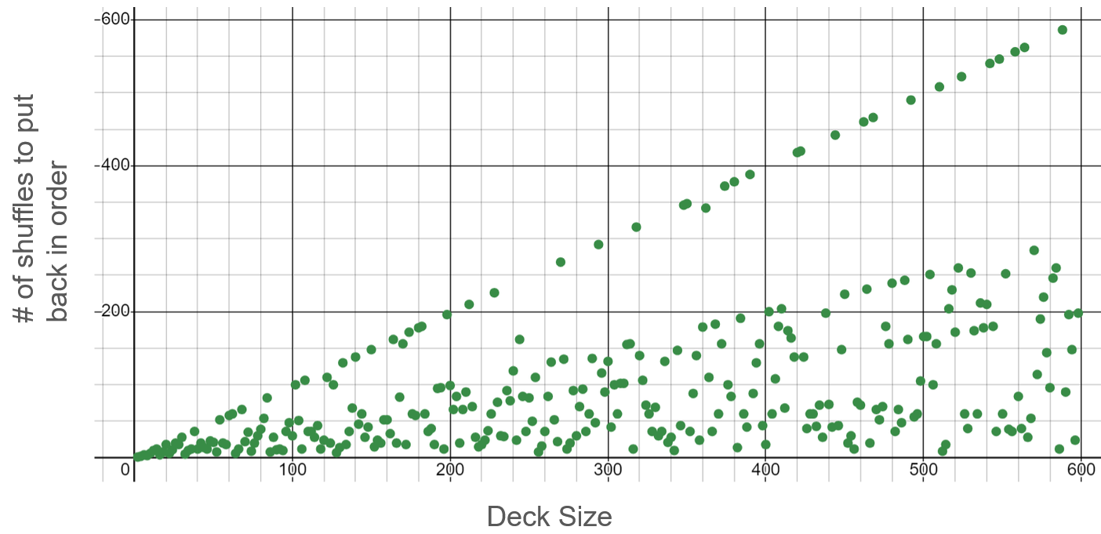
When mathematicians can’t figure out the answer to something, they’ll try and find an upper bound or a loower bound. Here’s that that means…
Upper bound: even if we can’t say exactly how many shuffles it takes, maybe we can say that the number must be less than ____________ (something). Jot some quick notes: what can you say about the apparent upper bound for this function?

Lower bound: even if we can’t say exactly how many shuffles it takes, maybe we can say that the number must be more than ____________ (something). Jot some quick notes: what can you say about the apparent lower-bound for this function?

Function Families
Look at all the function families below. You’ll need to have an intuitive sense of the shapes and basic characteristics of each of these families. You’ll sometimes need to recognize which of these is happening in a situation. Often you’ll want to decide which of these families has the features you want to build an equation to control something.

You’ll also be thinking about more general questions about what is and isn’t possible when working with types of functions, or combining them together in different ways.

Here are some things you’ll want to know. Not just know, but feel.
- The basic overall shape
- How the basic shape changes if you adjust parts of the equation.
- Important reference points (eg (0, 0) or (0, 1) or (1, 1))
- What growth triangles looks like in the curve (what type of growth they have)
- X and Y intercepts (if there are any)
- Asymptotes (if any)

Constant functions  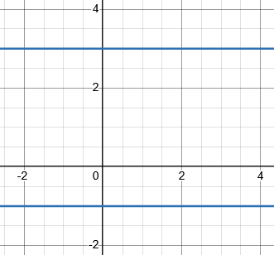  $y=3$  $$y=-1$$  In general:  $$y=k$$  for a real number k | Linear functions  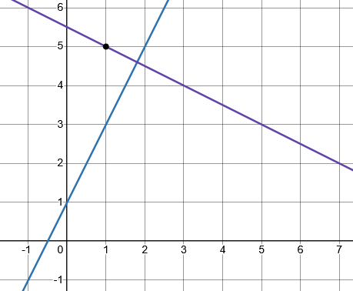  Slope intercept form  y = mx + b  Point slope form  y = m(x – h) + k
Even powers  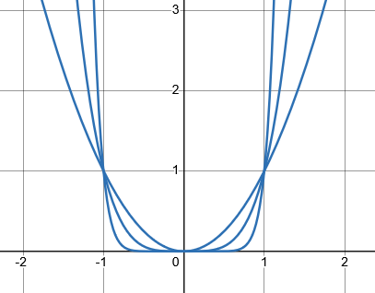  $$y=x^{2}$$  $$y=x^{4}$$  $$y=x^{6}$$ |  | Odd powers  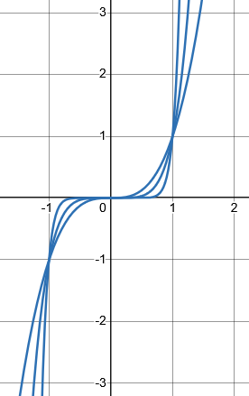  $$y=x^{3}$$  $$y=x^{5}$$  $$y=x^{7}$$
Even roots  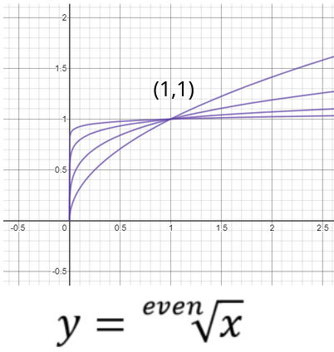 |  |  | Odd roots  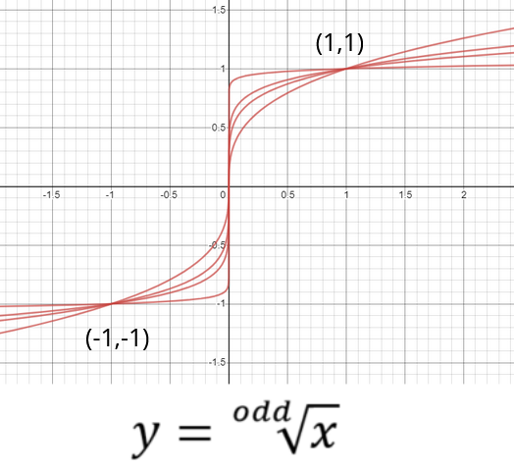
Exponential functions  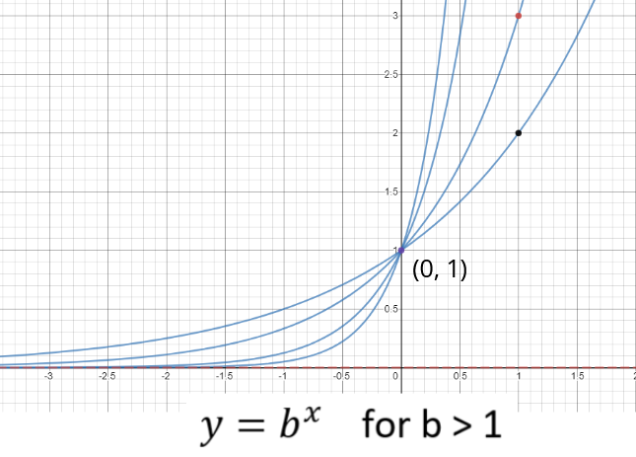 |  |  | Logarithmic functions  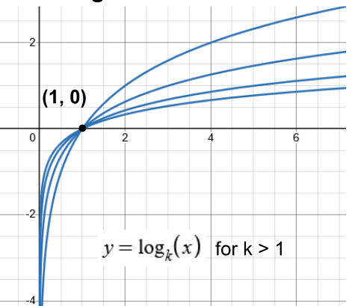
The $\frac{1}{x}$ function (reciprocal function)  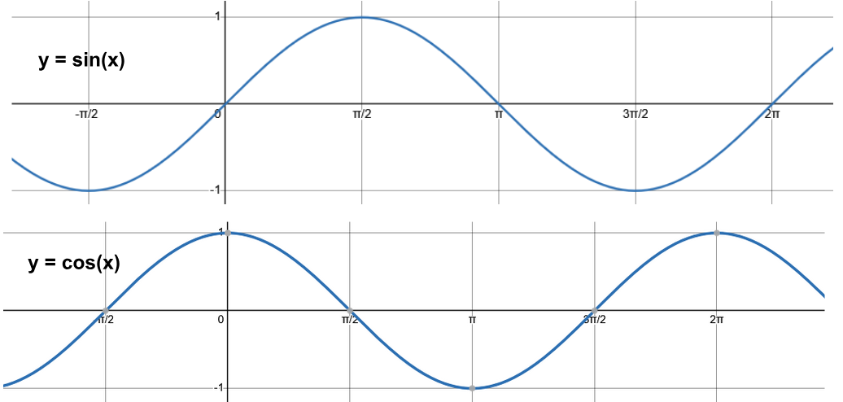  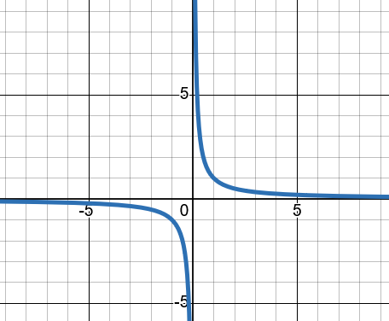 |  |  | Sine and cosine

Families of Functions – Insights and Takeaways Log
- Improving your mental picture: Note down what’s new for you about the shapes/features of the families.
- Why is it that way? Note down what you want to remember about why (or how to phrase your answer to why) for any of the graph features.

What Kind of Equation is Producing The Data?
Patterns in the growth.
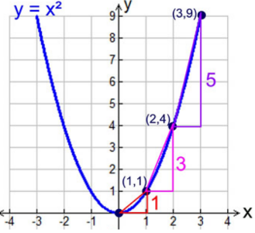
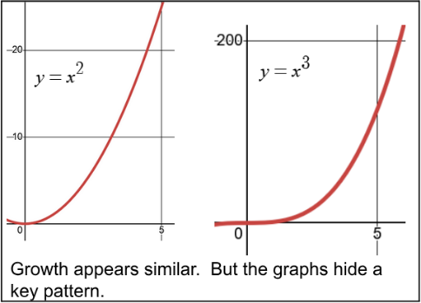

Here’s data from 3 different types of function. What connections do you notice?

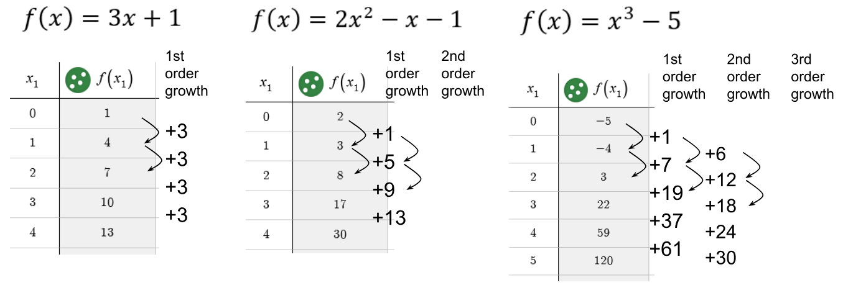

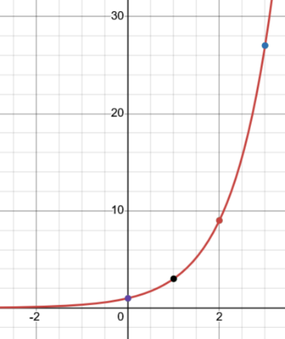
What about exponentials? How do you see their growth?
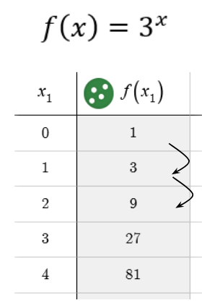


Does this example seem to match the growth for an exponential? What’s going on?
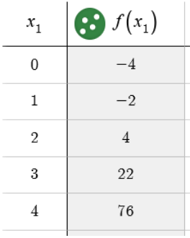

Take-away:

Solving systems of 3 linear equations (using elimination)

I assume you’ve seen this kind of thing before. If not, check the extra practice! Here’s an example:

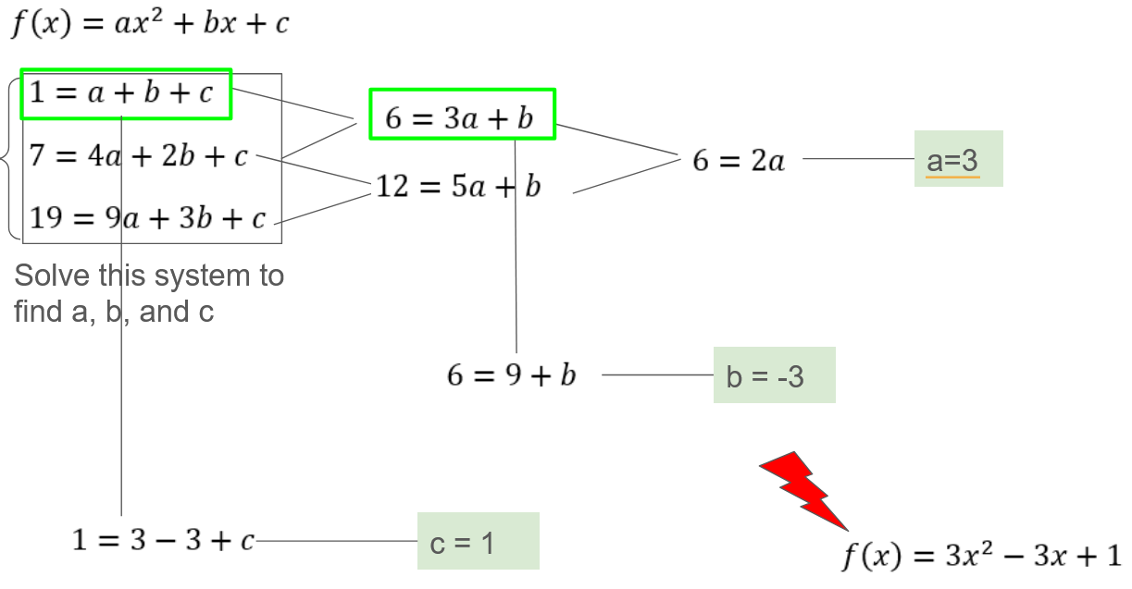

Plan a strategy for this one. We want to know the values of x, y and z which make all 3 equations true.

$$\left\{\begin{aligned}x+y-5z=-14 \\ -2x+6y+4z=2 \\ 3z-3y+6z=27\end{aligned}\right.$$

Verbally: why is it not helpful to just subtract or add one equation from another?
What could do you do?

Insights and Takeaways Log

Finding the Domain of Functions
The domain of f(x) is the set of values of x that produce a valid output. Here are three basic situations.
 | No restriction in the domain  $$f(x)=2^{x}$$ | Restricted at one value  $$f\left(x\right)=\frac{1}{x}$$ | Restricted for lots of values!  $$f\left(x\right)=\sqrt{x}$$
 | Domain: | Domain: | Domain:
Interval notation | Domain: | Domain: | Domain:
you can use the same kind of reasoning you did back in families of functions – name the unknown thing, and then ask what you know about it.
Why is $\frac{1}{0}$ undefined?

The learning in this section is about how to think about more complex cases in terms of these simpler ones. Finding domains isn’t really so important; breaking a complex equation into parts that you can understand separately is critical to a lot of important mathematical analysis!
Generalize the patterns. What would cause an undefined value in each of these?
$$f\left(x\right)=\frac{1}{x}$$  Since $\frac{1}{0}$ is undefined, f(x) won’t produce an output when x = 0. | $$f\left(x\right)=\frac{1}{2-23x}$$ | $$f\left(x\right)=\frac{1}{2^{\sin\left(x\right)}}$$

What about these? If these are real-valued functions, what would make the output undefined?
$$f\left(x\right)=\sqrt{x}$$  f(x) is undefined whenever $x<0$ | $$f\left(x\right)=\sqrt{2-23x}$$ | $$f\left(x\right)=\sqrt{2^{sin⁡(x)}}$$

Finding domains – Insights and Takeaways Log

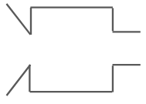

Function Composition
$$f\left(x\right)=x+3$$
$$g\left(x\right)=2x$$
$$f$$
$$g$$

Big idea: Chain two functions together.
The output of one goes to the input of another.

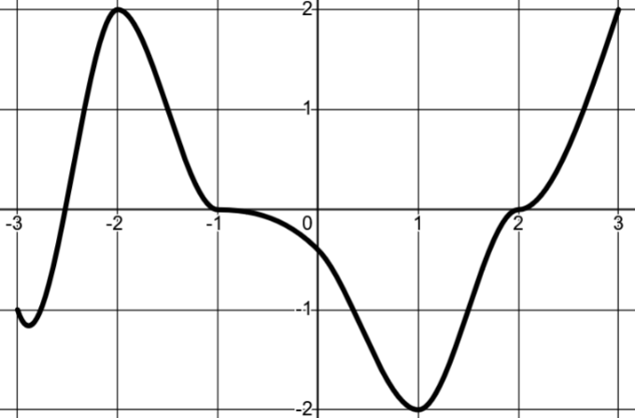
$$y=f\left(x\right)$$

Function composition – Insights and Takeaways Log

Function Inverses
Inverse functions reverse the process of the other one one
3 ideas (That are really 1 idea)
- Inverses “undo” each other
- “Swap x and y to solve”
- Inverses reflect diagonally over y = x

action “reverse” action to undo
$$f\left(x\right)=x+3$$
$g\left(x\right)=x^{2}$ **But actually not
$$x$$ | $$y$$
-2
-1
0
1
2

$$f\left(x\right)=x+3$$

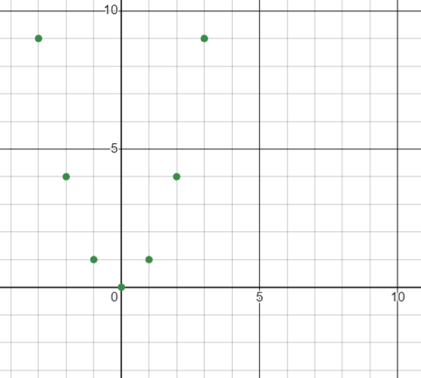
Some functions aren’t invertible
A function has ONE output for each input
CAUTION! $f\left(x\right)=x^{2}$ has NO INVERSE! (unless you domain-restrict it)
x | y
-3  -2  -1  0  1  2  3 | 9  4  1  0  1  4  9
y | x

$g\left(x\right)=x^{2}$ isn’t invertible becaue the inverse isn’t a function.
In regular English: Squaring is not a reversable process because …

BUT … $f\left(x\right)=x^{2}$ for $x≥0$ has an inverse of $f^{-1}\left(x\right)=\sqrt{x}$ .
Algebraic definition: f and g are inverses if…
“f undoes g for all x values”:
“g undoes f for all x values”:

Function Inverses – Insights and Takeaways Log

Inverses Notes 2
Why might a function not be invertible (reversible)?

What can you do to make it invertible (reversible)?

Try to invert: $f\left(x\right)={\left(x-3\right)}^{2}$ . Why is the result not a function?

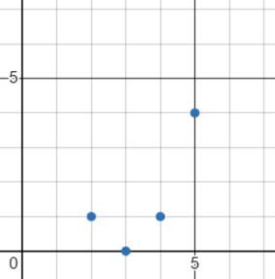
Find the inverse of $f\left(x\right)={\left(x-3\right)}^{2}$ for $x≥4$

Function Inverses – Insights and Takeaways Log

Transformations Notes
Recognize a transformed family | Transform something that’s NOT basic
$g\left(x\right)=-5^{x-2}$ . What’s the basic family? How has it been transformed? Sketch it. | Re-write $y=\frac{x+1}{3-x^{3}}$ so it’s been horizontally reflected and translated down by 1.

$g\left(x\right)=-5^{x-2}$ . What’s the basic family? How has it been transformed?
Sketch it by thinking how reference points move.

Re-write $y=\frac{x + 1}{3 - x^{3}}$ so it’s been horizontally reflected and translated down by 1.

Function Transformations – Insights and Takeaways Log

Finding the transformations you want
How could you write a $\sqrt{x}$ function that goes (100, 100) ?

How could you write a $\sqrt{x}$ function that goes through (0, 20) and (100, 100) ?

Finding transformations – Insights and Takeaways Log

General Insights and Takeaways Log

General Insights and Takeaways Log

